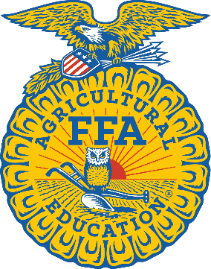
Livestock Showing Basics:
Who?
Any 4-H or FFA Member Grades 3-12
What?
***See reverse side for details about Livestock Categories and Estimated Costs***
When?
January 25-28, 2022
***Estimated Date: Official will be announced once information is
available***
Why?
Students have the opportunity to earn prizes including ribbons/rosettes, belt buckles and a place in the livestock auction.

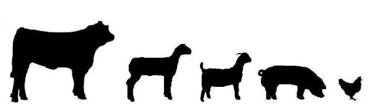

Livestock Categories:
- Swine- Approximately 4-5 Month Project
  - Estimated Costs:
    - Animal: $250-$800
    - Feed: Approximately $25/ 50 lb bag
    - Tack: Approximately $100 to start out
    - Validation: $17/animal
    - Entry Fee: $15/animal
    - Possible Vet Bills: $200 (only if necessary)
- Goats/Sheep- Approximately 5-6 Month Project
  - Estimated Costs:
    - Animal: $750- $2000
    - Feed: Approximately $25/ 50 lb bag
    - Tack: Approximately $100 to start out
    - Validation: $17/animal
    - Entry Fee: $15/animal
    - Possible Vet Bills: $200 (only if necessary)
- Broilers/Roasters: Approximately 6-8 Week Project
  - Estimated Costs:
    - Animal (sold in lots of 25 minimum purchase 25 maximum purchase 100): $43.75-$125
    - Feed: Approximately $25/ 50 lb bag
    - Tack: Approximately $100 to start out
    - Entry Fee: $15/pen
- Rabbits: Approximately 6-week project
  - Estimated Costs:
    - Animal (sold in pens of 4): $250/ pen
    - Feed: Approximately $25/ 50 lb bag
    - Tack: Approximately $50 to start out
    - Entry Fee: $15/pen
- Cattle- Approximately 9-10 Month Project
  - Estimated Costs:
    - Animal: $900- $2000
    - Feed: Approximately $25/ 50 lb bag
    - Tack: Approximately $150 to start out
    - Validation: $22/animal
    - Entry Fee: $15/animal
    - Possible Vet Bills: $500 (only if necessary)
- Turkeys- Approximately 2-month project
  - Estimated Costs:
    - Animal (sold in lots of 5 max purchase 75): $21.25-$318.75
    - Feed: Approximately $25/ 50 lb bag
    - Tack: Approximately $100 to start out
    - Entry Fee: $15/animal

