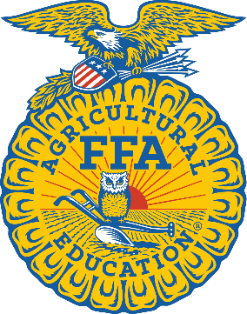
Homemaking Show Basics:
Who?
Any 4-H, FFA, FCCLA Member Grades 3-12
What?
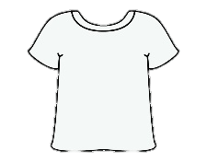
Entry Divisions include:
- Clothing Division
  - Ex. Shirts, Shorts, Sleep wear, Occasion Costumes, etc.
- Food Division (Canceled in 2021 Due to COVID status for 2022 still pending)
  - Ex. Specialty Cookies, Cupcakes, Cinnamon Rolls, Pecan Pie, etc.
- Textiles Division
  - Ex. Apron, Table Linens, Needlepoint, Pillows, etc.
- Handy Crafts Division
  - Ex. Jewelry, Wood Work, Bead Art, Decoupage, etc.
- Fine Arts Division
  - Ex. Pencil Drawings, Ink, Acrylic Paintings, Pottery, etc.
- Photography Division
  - Ex. Animals Domestic/Wildlife, Elements of Design, Food, Plant/Flora, etc.
When?
January 25-28, 2022
***Estimated Date: Official will be announced once information is
available***
Where?
San Patricio County Fairgrounds & Event Center
219 W. 5th St.
Sinton, TX 78387
Why?
Students have the opportunity to earn prizes including ribbons/rosettes, belt buckles, cash prizes, and a place in the livestock auction.

